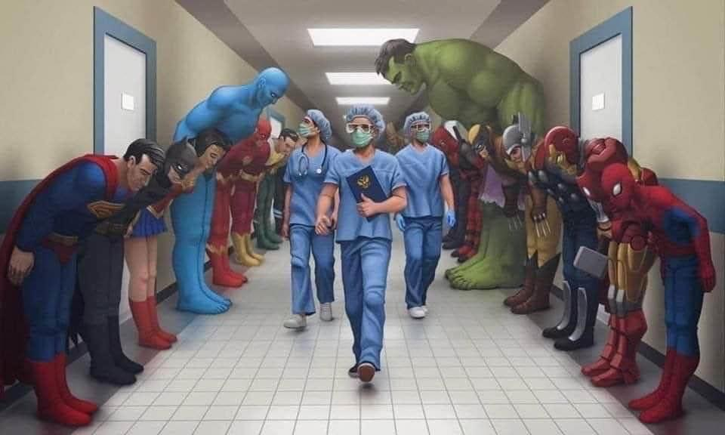
Superhero’s

Image from The Literacy Shed

- List the names of the SUPERHEROES you can see in the picture
- Can you add speech bubbles or thought clouds to the characters in the image?
- What does the phrase ‘a picture tells a thousand words’ mean to you?
- Draw a picture of your own version of an NHS superhero

