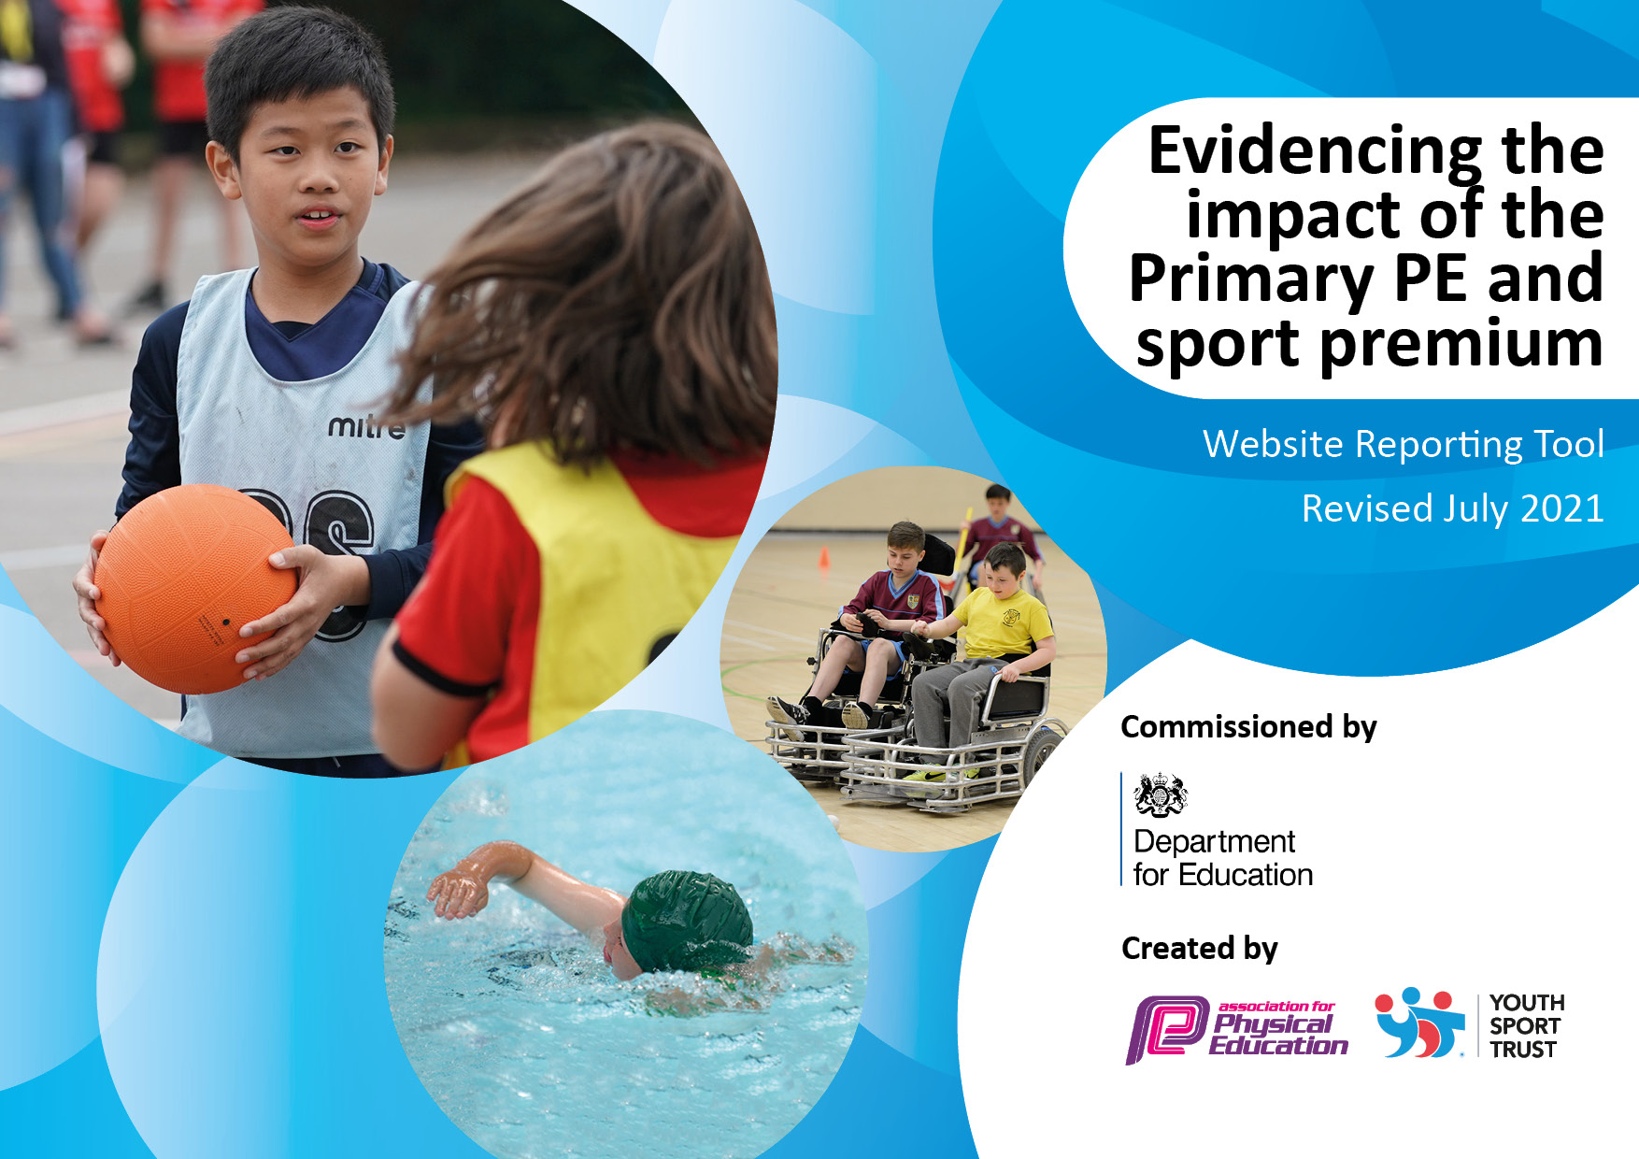
THINGWALL PRIMARY SCHOOL – PE ACTION PLAN 2022_23

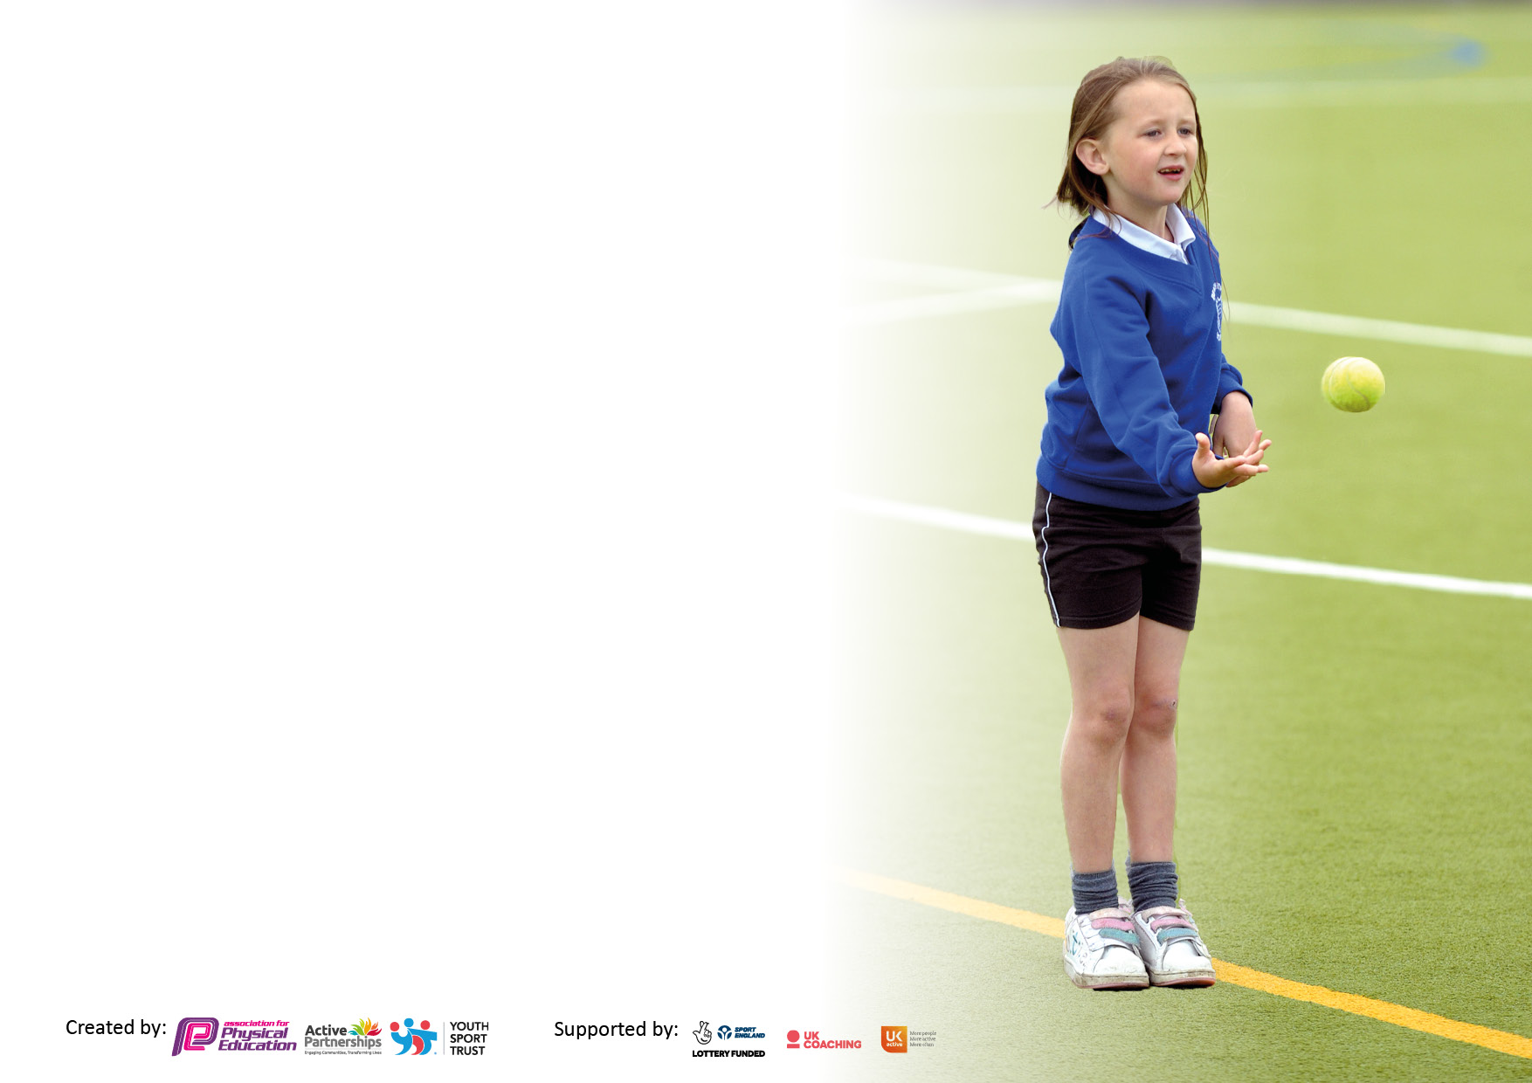

It is important that your grant is used effectively and based on school need. The Education Inspection Framework makes clear there will be a focus on ‘whether leaders and those responsible for governors all understand their respective roles and perform these in a way that enhances the effectiveness of the school’.

Under the Quality of Education Ofsted inspectors consider:
Intent - Curriculum design, coverage and appropriateness
Implementation - Curriculum delivery, Teaching (pedagogy) and Assessment
Impact - Attainment and progress

To assist schools with common transferable language this template has been developed to utilise the same three headings which should make your plans easily transferable between working documents.

Schools must use the funding to make additional and sustainable improvements to the quality of Physical Education, School Sport and Physical Activity (PESSPA) they offer. This means that you should use the Primary PE and sport premium to:

- Develop or add to the PESSPA activities that your school already offer
- Build capacity and capability within the school to ensure that improvements made now will benefit pupils joining the school in future years
- The Primary PE and sport premium should not be used to fund capital spend projects; the school’s budget should fund these.

Pleasevisitgov.ukfortherevisedDfEguidanceincludingthe5keyindicatorsacrosswhichschoolsshoulddemonstrate animprovement.Thisdocumentwillhelpyoutoreviewyourprovisionandtoreportyourspend.DfEencouragesschools to use this template as an effective way of meeting the reporting requirements of the Primary PE and sport premium.

We recommend you start by reflecting on the impact of current provision and reviewing the previous spend.

Schools are required to publish details of how they spend this funding, including any under-spend from 2019/2020, as well as on the impact it has on pupils’ PE and sport participation and attainment. All funding must be spent by 31st July 2022.

We recommend regularly updating the table and publishing it on your website throughout the year. This evidences your ongoing self-evaluation of how you are using the funding to secure maximum, sustainable impact. Final copy must be posted on your website by the end of the academic year and no later than the 31st July 2021. To see an example of how to complete the table please click HERE.
Created by: Supported by:

Details with regard to funding
Please complete the table below.

Total amount carried over from 2019/20 | £ None
Total amount allocated for 2020/21 | £ 17704
How much (if any) do you intend to carry over from this total fund into 2021/22? | £ None
Total amount allocated for 2021/22 | £ 17704
Total amount of funding for 2021/22. To be spent and reported on by 31st July 2022. | £ 17704
Swimming Data
Please report on your Swimming Data below.

Meeting national curriculum requirements for swimming and water safety.  N.B. Complete this section to your best ability. For example you might have practised safe self-rescue techniques on dry land which you can then transfer to the pool when school swimming restarts.  Due to exceptional circumstances priority should be given to ensuring that pupils can perform safe self rescue even if they do not fully meet the first two requirements of the NC programme of study | 2022 to 2023
What percentage of your current Year 6 cohort swim competently, confidently and proficiently over a distance of at least 25 metres?  N.B. Even though your pupils may swim in another year please report on their attainment on leaving primary school at the end of the summer term 2021.  Please see note above | %
What percentage of your current Year 6 cohort use a range of strokes effectively [for example, front crawl, backstroke and breaststroke]?  Please see note above | %
What percentage of your current Year 6 cohort perform safe self-rescue in different water-based situations? | %
Schools can choose to use the Primary PE and sport premium to provide additional provision for swimming but this must be for activity over and above the national curriculum requirements. Have you used it in this way? | Yes/No

Action Plan and Budget Tracking
Capture your intended annual spend against the 5 key indicators. Clarify the success criteria and evidence of impact that you intend to measure to evaluate for pupils today and for the future.

Academic Year: 2022/23 | Total fund allocated: | Date Updated:
Key indicator 1: The engagement of all pupils in regular physical activity – Chief Medical Officers guidelines recommend that primary school pupils undertake at least 30 minutes of physical activity a day in school |  |  |  | Percentage of total allocation:
 |  |  |  | %
Intent | Implementation |  | Impact
Your school focus should be clear what you want the pupils to know and be able to do and about  what they need to learn and to  consolidate through practice: | Make sure your actions to achieve are linked to your intentions: | Funding allocated: | Evidence of impact: what do pupils now know and what can they now do? What has changed?: | Sustainability and suggested next steps:
Encourage pupils to cycle, park and stride, walk or scoot to school  Continue to offer a wide range of activities encouraging all pupils to increase physical and mental fitness during the school day (i.e. not only in PE lessons)  Continue to promote ‘Daily Mile’  Continue to develop use of lunchtime clubs supported Midday Assistants and Year 6 Playtime Leaders.  External visitors to school to promote and motivate.  Review ease of access to PE equipment at back of hall – separate playtime equipment from PE teaching resources. | Identify a week to promote this activity and set up reward scheme to celebrate (and monitor)  Staff to explore ways to get all pupils active (outside of PE lessons).  Wake and Shake, Boogie Beebies, Cosmic Yoga  Fun Fit Club in the mornings incorporating ‘Beep Test’. Certificates to reward progress.  Run a Girls’ Active Club  To encourage participation in Daily Mile, organise a school charity fundraiser (sponsored run/walk) to motivate pupils and raise funds for additional lunchtime play equipment.  Use School Games Active Recovery Hub for ideas. Explore Jenny Mosely.  Encourage chalking, hula hooping, jumping, follow the leader  Famous sporting personalities (Sports for Schools) and fun activity days e.g. Freddie Fit  Train play leaders to store equipment properly and to take care of it. Replace equipment annually, as required. | £ | Increased parent involvement and support, a more active school and increased engagement of all pupils (including less active young people.)  Measurement showing increased levels of fitness.  More girls involved in sport.  Active pupils and funds for PE!  Pupils engaged in fun activities at lunchtimes. Increased fitness and improved behaviour.  Motivated and inspired pupils enjoyed physical activity.  Easier access to resources.
Key indicator 2: The profile of PESSPA being raised across the school as a tool for whole school improvement |  |  |  | Percentage of total allocation:
 |  |  |  | %
Intent | Implementation |  | Impact
Your school focus should be clear what you want the pupils to know and be able to do and about  what they need to learn and to  consolidate through practice: | Make sure your actions to achieve are linked to your intentions: | Funding allocated: | Evidence of impact: what do pupils now know and what can they now do? What has changed?: | Sustainability and suggested next steps:
Develop a PE team to promote the subject across both key stages and to develop Forest School projects.  Explore ways to increase opportunity to develop active learning outdoors across the curriculum  Measure and support improved physical and mental health  Involve Y6 pupils in running of intra-house competitions in school.  Continue to provide role models to inspire sporting achievement and to exemplify positive characteristics. | Regular half termly meetings to review progress against identified objectives.  Using LCR bid monies to promote gardening activities and wildlife surveys  Set up Forest School projects  Train TAs to assess Year 2 pupils against 19 Normal Physical Milestones (NPMs). Pupils achieving lower than 14, undertake a daily 10 minute core stability exercise programme for 6 weeks before being reassessed.  Meetings to organise timetabled events  Use PE noticeboard to promote role models amongst key sporting figures. | £ | Pupils develop a love for the outdoors, acquire new knowledge, develop skills and become more active outdoors.  Increased physical fitness, improving mental wellbeing resulting in accelerated progress academically.  Increased pupil involvement (and responsibility) for setting up and leading sporting events to benefit all pupils in school.  Chn understand that determination and resilience are key attributes to success in life including sport.

Key indicator 3: Increased confidence, knowledge and skills of all staff in teaching PE and sport |  |  |  | Percentage of total allocation:
 |  |  |  | %
Intent | Implementation |  | Impact
Your school focus should be clear | Make sure your actions to | Funding | Evidence of impact: what do | Sustainability and suggested
what you want the pupils to know | achieve are linked to your | allocated: | pupils now know and what | next steps:
and be able to do and about | intentions: |  | can they now do? What has
what they need to learn and to |  |  | changed?:
consolidate through practice:
Ensure that high quality (and quantity) of provision continues in the absence of Premier Sports.  Staff knowledge and confidence developed to enhance quality and quantity of provision.  Improve use of assessment information, supporting progression of skills as pupils move through school  Audit/purchase and store (fund raise via sponsored event?) PE resources to ensure availability for lessons | Increased shared teaching with support from PE Lead.  Audit and provide CPD programme to support.  Measure levels of progress against identified skills (Skills Sheet) and use data to inform provision.  Continue to use and analyse video evidence for improvement.  Review storage to secure and separate PE equipment from lunchtime play resources. | £ | Increased knowledge, confidence and skills to deliver high quality PE lessons across the school.  Attainment and enjoyment improves across all areas of the subject.  Motivated pupils assess and evaluate their performance in lessons  Availability of resources reducing preparation time (and stress) for teachers.
Key indicator 4: Broader experience of a range of sports and activities offered to all pupils |  |  |  | Percentage of total allocation:
Intent | Implementation |  | Impact
Your school focus should be clear | Make sure your actions to | Funding | Evidence of impact: what do | Sustainability and suggested
what you want the pupils to know | achieve are linked to your | allocated: | pupils now know and what | next steps:
and be able to do and about | intentions: |  | can they now do? What has
what they need to learn and to |  |  | changed?:
consolidate through practice:
Add new sports to curriculum and clubs  External specialist coaches to lead clubs for pupils  Raise awareness of disability issues, increasing understanding of disability (not seeing the disability but the person behind it)  Explore ways to develop a more inclusive sports day.  Introduction of and Bikeability (Year 5 or 6)  Introduce ‘Forest School’ activities for younger pupils. | Produce timetable for all clubs.  Monitor attendance of all pupils at clubs. Review costing structure for clubs to ensure that it is accessible for all pupils  Introduce ‘Passport’ reward scheme to encourage improved attendance at clubs  Look to local clubs and involve young talented pupils to support training.  Increase links with specialist coaches to enhance the quality of provision in the future. e.g. fencing and archery. Also Cheshire Cricket Club)  Set up a whole school sports activity inclusion day to promote activities accessible to all pupils irrespective of one’s disabilities; to include boccia, blind football, new age ‘kurling,’ sitting volleyball.  Continue to use and explore Youth Sports Trust materials to extend provision for all.  Invite a Paralympic athlete into school?  Contact LA and timetable sessions  PE team to set up projects for the school year. | £ | Increased attendance at clubs with pupils motivated to collect stamps for passports.  Quality sessions delivered by talented young sports people, in turn motivating and inspiring pupils.  Improved links with other schools and sports clubs.  Wider awareness of inclusion and disability, resulting in greater understanding  Increased pupil awareness of road safety.  Increased number of pupils being active in the natural world. New experiences developing pupil confident and self-esteem.

Key indicator 5: Increased participation in competitive sport |  |  |  | Percentage of total allocation:
 |  |  |  | %
Intent | Implementation |  | Impact
Your school focus should be clear | Make sure your actions to | Funding | Evidence of impact: what do | Sustainability and suggested
what you want the pupils to know | achieve are linked to your | allocated: | pupils now know and what | next steps:
and be able to do and about | intentions: |  | can they now do? What has
what they need to learn and to |  |  | changed?:
consolidate through practice:
Use Wirral Games forum to organise sporting competitions across the school.  Explore award schemes to encourage pupils to achieve personal bests. Develop strategies to help pupils cope with disappointment of losing or failing to achieve targets.  Set up house competitions led by class teachers related to PE curriculum  Set up personal challenge zones at lunchtimes (using best times, scores, distances etc. to motivate and promote.)  Improved facilities to be maintained for future use.  Purchase new football posts | Host more sports’ fixtures and Increase use of school premises for sports matches  Use schemes set up by sporting associations e.g. English Schools’ Athletic Association (ESAA) award scheme.  Timetable events for each term. Set up House Challenge week.  Appoint ‘School Sports Crew,’ across houses to lead. | £ | Raising profile of PE in school.  Greater involvement for all pupils at school – increased excitement on match days.  All pupils involved and motivated to achieve at their best.  All pupils involved in competitive house sport.  Increased challenge for pupils to improved fitness and personal goals.  Improved behaviour at lunchtimes.

Signed off by
Head Teacher: | D L Evans
Date: | 18.07.22
Subject Leader: | J E Yardley
Date: | 18.07.22
Governor: | G Lester
Date: | 20.07.22

