

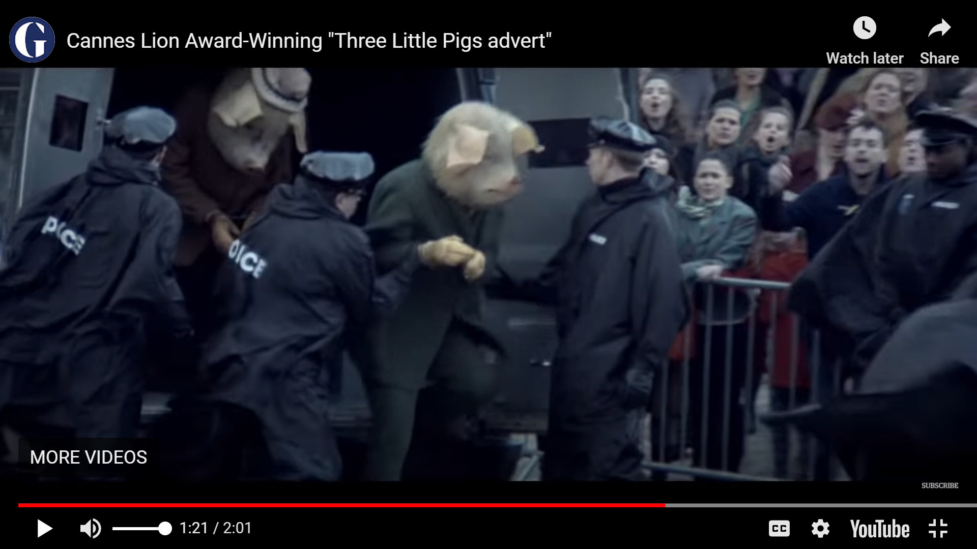

The three pigs arriving at Fairytale Police Station.

explained, “We have checked Mr Wolf’s medical records, and it appears that he suffered from severe asthma and wouldn’t have had the puff to blow out a candle, let alone a house.”

Upon further investigation, the detectives found that the pigs had been in serious debt for several months and were desperate for money.

The three little pigs will be trialled tomorrow at 6pm and, if found guilty, will serve a total of 25 years in prison. Reported by: T Pritchard

Yesterday, Saturday 21st February at approximately 2pm, three little pigs were arrested - by armed police - for committing insurance fraud and murder. The innocent murdered animal in question was Mr T. Wolf, who suddenly disappeared last week and was found dead in a boiling pot of water in the brick home of one of the pigs.

Mr Wolf’s family are devastated at this news and commented that he was a loving husband and father and would never hurt a fly.

The detectives on this case have made some major progress in the last 24 hours. Using a huff and puff simulator, they found that although the pigs claimed Mr Wolf had blown two of their houses down, he would not have been able to do so. Detective A. Squirrel (from Fairytale Police Department)

**Three pigs arrested for telling porky pies and framing innocent wolf.**

**TROUBLESOME TROTTERS BEHIND BARS**