Ball of Fire in the sky by Jacob W
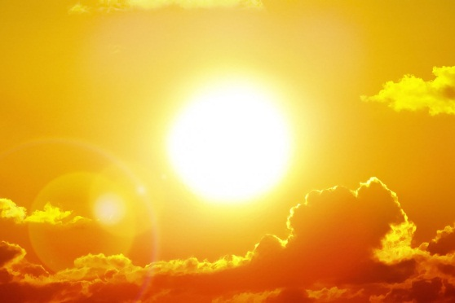
If you asked what the Sun is
People would tell you
In their most cheerful voices:

The sun is warm ball
Beating down on your skin,

The sun is a glow in the sky
Lighting a path through the darkness,

The sun is the winter’s ending
Breathing life back into earth,

Let the comforting warmth of the sun
Wash over you,

See it watching over you
In the sky above.

