PSHE Policy
(Personal, Social, Health and Economic Education)

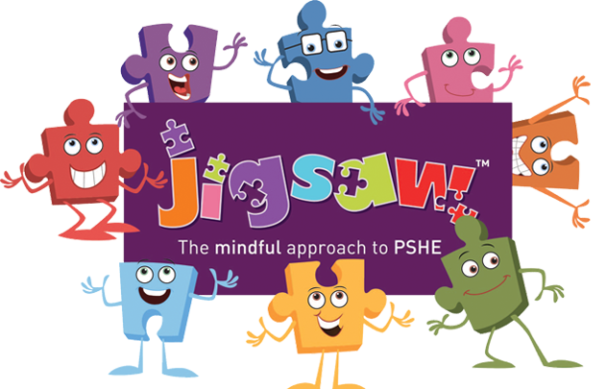

This policy was adopted ……………………………………….….. May 2022

This policy is due for review ………………………………………….. November 2025

Signed: …………………………………………………………………………………..
This PSHE policy should be read in conjunction with (but not limited to) SRE Policy, Safeguarding Policy, Inclusion Policy, Behaviour Policy, Anti-Bullying Policy, Equality Policy

Context
All schools must provide a curriculum that is broadly based, balanced and meets the needs of all pupils. Personal, social, health and economic (PSHE) education is an important and necessary part of all pupils’ education. All schools should teach PSHE and draw on good practice- this expectation is outlined in the introduction to the national curriculum.
PSHE is a non-statutory subject and can encompass many areas of study. Teachers are best placed to understand the needs of their pupils, we use PSHE education to build, where appropriate, on the statutory content already outlined in the national curriculum, the basic school curriculum and in statutory guidance on: drug education, financial education, sex and relationship education (SRE) and the importance of physical activity and diet for a healthy lifestyle.
Under section 78 of the Education Act 2002 and the Academies Act 2010, a PSHE curriculum:
• Promotes the spiritual, moral, cultural, mental and physical development of pupils at the school and of society, and
• Prepares pupils at the school for the opportunities, responsibilities and experiences of later life.

PSHE at Thingwall
At Thingwall Primary School, the physical and emotional well-being of our children is a priority. We nurture and educate our pupils in order to help them to develop the knowledge, understanding and skills needed to live happy, healthy and successful lives, now and in the future. We promote our pupils’ spiritual, moral, social and cultural development and teach Personal, Social, Health Education as a whole-school approach. The Jigsaw Programme offers a comprehensive and thorough Scheme of Work which brings consistency and progression to our children’s learning in this vital curriculum area, the scheme also supports the “Personal Development” and “Behaviour and Attitude” aspects required under the Ofsted Inspection Framework, as well as significantly contributing to the school’s Safeguarding and Equality Duties and the SMSC (Spiritual, Moral, Social, Cultural) development opportunities provided for our children.

What do we teach when and who teaches it?
Jigsaw covers all areas of PSHE for the primary phase including statutory Relationships and Health Education. The table below gives the learning theme of each of the six Puzzles (units) and these are taught across the school.
Term | Puzzle (Unit) | Content
Autumn 1 | Being Me In My World | Understanding identity and how I fit well in the class, school and global community. Jigsaw Charter established
Autumn 2 | Celebrating Difference | Anti-bullying (including cyber and homophobic bullying)
Spring 1 | Dreams and Goals | Goal setting, aspirations, who do I want to become, what I would like to do for work and contributing to society
Spring 2 | Healthy Me | Drug and alcohol education, self-esteem and confidence, healthy lifestyle choices, sleep, nutrition, rest and exercise
Summer 1 | Relationships | Understanding friendship, family and other relationships, conflict resolution and communication skills, bereavement and loss
Summer 2 | Changing Me | Relationships and Sex Education in the context of managing change positively

We allocate 1 lesson (approx. 45mins to 1 hour) to PSHE each week in order to teach the PSHE knowledge and skills in a developmental and age-appropriate way.
These explicit lessons are reinforced and enhanced in many ways through assemblies and collective worship, our learning charter and through relationships (child to child, adult to child and adult to adult) across the school. We aim to ‘live’ what is learnt and apply it to everyday situations in the school community.
Class teachers deliver the weekly lessons to their own classes.

Working with Parents
Jigsaw is keen to support schools to appropriately engage parents/carers with their children’s PSHE/HWB/RSE learning and provides materials that can be shared with parents/carers. These can be found on our website.
Parents/carers will be notified by letter before the start of the Summer Terms puzzle ‘Changing Me’, when sensitive topics are due to be delivered. We believe that through this mutual exchange of knowledge and information, children will benefit from being given consistent messages about their changing body and their increasing responsibilities. Many are comfortable with the school taking the lead on planned learning, but want to be prepared to answer their children’s subsequent questions or simply talk together about their children’s learning. We will notify parents when particular aspects of sex and relationships education will be taught.

Assessment
Pupil understanding and progress is assessed through a variety of methods, including formative and summative processes. These include pre- and post-topic mind maps, floor books, drawings, task outcomes, questioning and observations. Teachers liaise with staff during transition meetings to reflect on topics covered throughout the academic year, they discuss/share comments with the teaching team and PSHE lead as part of the monitoring cycle.
Pupils’ progress in RSE is assessed within the science curriculum, PE curriculum and PSHE. We monitor regularly considering individual needs, maturity, age, ability and personal circumstances using pupil, staff and parent voice, learning walks and displays.

Resources
Class teachers have their own resources for delivering each puzzle, each class has their own named Puzzle Piece, Jerry the Cat and chime bar for delivering each lesson. We have additional text resources in the library and the PSHE coordinator holds a selection of reference materials for teaching sensitive issues.

Monitoring and Review
The planning and coordination of the teaching in PSHE are the responsibility of the PSHE subject leader, who also:
- supports colleagues in their teaching, by keeping informed about current developments in the subject and by providing a strategic lead and direction for PSHE;
- gives the headteacher an annual summary report in which s/he evaluates the strengths and weaknesses in the subject, and indicates areas for further improvement;
- uses specially allocated, regular management time to review evidence of the children’s work and to observe PSHE lessons across the school.
This policy will be reviewed every two years.

Equality
At Thingwall Primary School we promote respect for all and value every individual child. We also respect the right of our children, their families and our staff, to hold beliefs, religious or otherwise.
Associated Jigsaw PSHE documents
• Jigsaw 3-11 and statutory Relationships and Health Education (mapping document)
• Including and valuing all children. What does Jigsaw teach about LGBTQ relationships?

