Andy Goldsworthy
- Born 26th July 1956 in Cheshire, England.
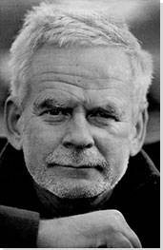
- He worked on farms as he grew up as a labourer and this inspired his sculpture work.
- Lives in Penpont in Scotland and has 4 children. He lives with his partner.
- He is sculptor, photographer and environmentalist, producing art and sculptures in natural settings.
- He studied fine art at university and received a degree.
- He has lived in different places such as Yorkshire, Lancashire and Cumbria before settling in Scotland.
- He is inspired by the environment and his art often uses pine cones, brightly coloured flowers, stone, twigs and thorns.
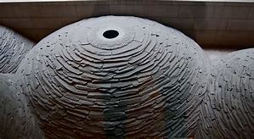
- His sculptures include “Chalk Stones,” “Roof,” Stone River,” and “Three Cairns.”
- A film was made about him in 2001 called Rivers and Tides.
- He has won lots of awards such as North West Arts Award, Northern Arts award and Scottish Arts Council Award.

