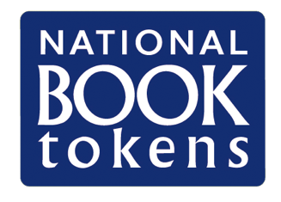
CREATE A
National Book Token
DESIGN!

Win a £10 National Book Token – emblazoned with your design – for every child in class.
If you do not have a printer and/or scanner, you can take a photo of the artwork and complete the details below. Please try to send a high-quality photo that shows the artwork clearly. The artwork can be created on an A4 piece of paper

Child’s name:
Child’s age:
Your name:
Your relationship to the child (please bold):
Teacher
Parent/guardian
Other (please specify):
Your email address:
School name:
I give permission for the above-named child to enter the competition
I accept the terms and conditions*
I have completed the entry form on nationalbooktokens.com/create
Please type your name to agree:

*Terms and conditions can be found at www.nationalbooktokens.com/create

