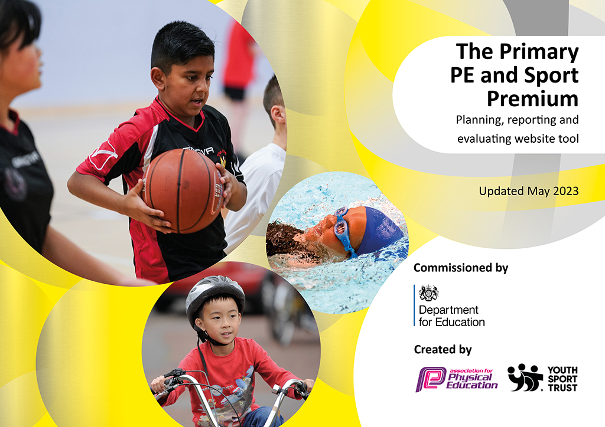
Thingwall Primary School PE Action Plan 2022_23
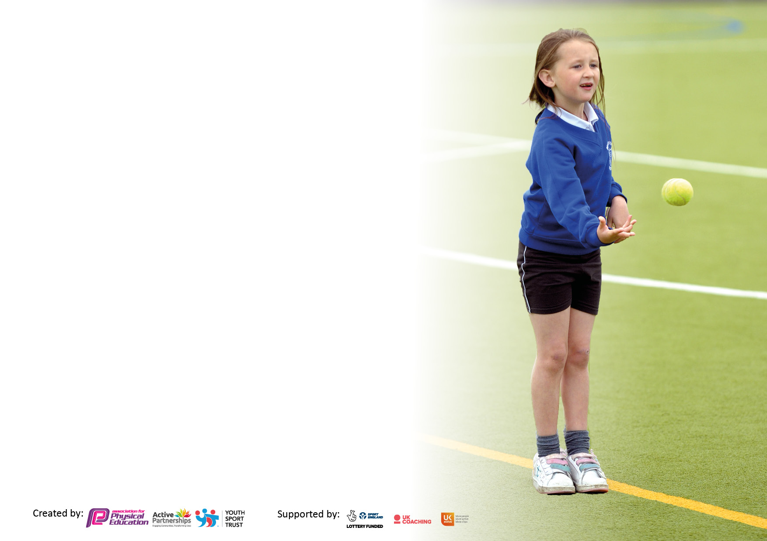

It is important that your grant is used effectively and based on school need. The Education Inspection Framework makes clear there will be a focus on ‘whether leaders and those responsible for governors all understand their respective roles and perform these in a way that enhances the effectiveness of the school’.

Under the Quality of Education Ofsted inspectors consider:
Intent - Curriculum design, coverage and appropriateness
Implementation - Curriculum delivery, Teaching (pedagogy) and Assessment
Impact - Attainment and progress

To assist schools with common transferable language this template has been developed to utilise the same three headings which should make your plans easily transferable between working documents.

Schools must use the funding to make additional and sustainable improvements to the quality of Physical Education, School Sport and Physical Activity (PESSPA) they offer. This means that you should use the Primary PE and sport premium to:

- Develop or add to the PESSPA activities that your school already offer
- Build capacity and capability within the school to ensure that improvements made now will benefit pupils joining the school in future years
- The Primary PE and sport premium should not be used to fund capital spend projects; the school’s budget should fund these.

Pleasevisitgov.ukfortherevisedDfEguidanceincludingthe5keyindicatorsacrosswhichschoolsshoulddemonstrate animprovement.Thisdocumentwillhelpyoutoreviewyourprovisionandtoreportyourspend.DfEencouragesschools to use this template as an effective way of meeting the reporting requirements of the Primary PE and Sport Premium.

We recommend you start by reflecting on the impact of current provision and reviewing the previous spend.

Schools are required to publish details of how they spend this funding, including any under-spend from 2021/2022, as well as on the impact it has on pupils’ PE and sport participation and attainment. All funding must be spent by 31st July 2023.

We recommend regularly updating the table and publishing it on your website throughout the year. This evidences your ongoing self-evaluation of how you are using the funding to secure maximum, sustainable impact. Final copy must be posted on your website by the end of the academic year and no later than the 31st July 2023. To see an example of how to complete the table please click HERE.

Details with regard to funding
Please complete the table below.

Total amount carried over from 2021/22 | £0
Total amount allocated for 2021/22 | £17760
How much (if any) do you intend to carry over from this total fund into 2022/23? | £0
Total amount allocated for 2022/23 | £17820
Total amount of funding for 2023/23. To be spent and reported on by 31st July 2023. | £ 17820
Swimming Data
Please report on your Swimming Data below.

Meeting national curriculum requirements for swimming and water safety.

N.B. Complete this section to your best ability. For example you might have practised safe self-rescue techniques on dry land which you can then transfer to the pool when school swimming restarts.
Due to exceptional circumstances priority should be given to ensuring that pupils can perform safe self rescue even if they do not fully meet the first two requirements of the NC programme of study
What percentage of your current Year 6 cohort swim competently, confidently and proficiently over a distance of at least 25 metres?  N.B. Even though your pupils may swim in another year please report on their attainment on leaving primary school at the end of the summer term 2022.  Please see note above | 66%
What percentage of your current Year 6 cohort use a range of strokes effectively [for example, front crawl, backstroke and breaststroke]?  Please see note above | 46%
What percentage of your current Year 6 cohort perform safe self-rescue in different water-based situations? | 63%
Schools can choose to use the Primary PE and sport premium to provide additional provision for swimming but this must be for activity over and above the national curriculum requirements. Have you used it in this way? | Yes/No

Action Plan and Budget Tracking
Capture your intended annual spend against the 5 key indicators. Clarify the success criteria and evidence of impact that you intend to measure to evaluate for pupils today and for the future.

Academic Year: 2022/23 | Total fund allocated: | Date Updated:
Key indicator 1: The engagement of all pupils in regular physical activity – Chief Medical Officers guidelines recommend that primary school pupils undertake at least 30 minutes of physical activity a day in school |  |  |  | Percentage of total allocation:
 |  |  |  | 1%
Intent | Implementation |  | Impact
Your school focus should be clear what you want the pupils to know and be able to do and about  what they need to learn and to  consolidate through practice: | Make sure your actions to achieve are linked to your intentions: | Funding allocated: | Evidence of impact: what do pupils now know and what can they now do? What has changed?: | Sustainability and suggested next steps:
Enable active playground scheme to extend opportunities for all pupils to enjoy physical activity at playtimes  Take part in ‘Living Streets’ Walk to School events  Continue to promote ‘Daily Mile’ | Work with new lunchtime supervisors to ensure that all pupils enjoy regular physical activity in a safe environment  Appoint new Y5/6 Play Leaders (include less active Y6 pupils to support their physical development) to lead play activity on both playgrounds  Develop a half termly programme (with pupil input) to ensure that activities are age appropriate and accessible  Actively promote across whole school (fun challenge and prizes for winning class)  Formalise with termly certificates for pupils (most laps, most improved etc) | £200 for promotional materials and published motivation resources | Lunchtime supervisors are able to offer all pupils ideas for happy play  Pupils interacting happily together whilst enjoying active play (not just football!) showing increased support for their peers – happier children, happier playtimes!  Higher percentage of pupils (all ages) involved in a wide range of age appropriate activities/games  Opportunity for Y5/6 pupils to take on leadership roles  Increased number of pupils walking (or scooting) to school  Positive involvement in physical activity for wider community  Reduced congestion near to school  Cleaner Air  Environment gain  Increased motivation for pupils to improve/increase laps and therefore, physical fitness | - Lunchtime supervisors are confident in their ability to continue programme  - Year 5 pupils are able to continue to support programme (& incoming Y5 pupils, when in Y6  - Programme in place as a starting point for future development  Initiative included as an termly/annual event  Developing healthy habits for the future
Key indicator 2: The profile of PESSPA being raised across the school as a tool for whole school improvement |  |  |  | Percentage of total allocation:
 |  |  |  | %
Intent | Implementation |  | Impact
Your school focus should be clear what you want the pupils to know and be able to do and about  what they need to learn and to  consolidate through practice: | Make sure your actions to achieve are linked to your intentions: | Funding allocated: | Evidence of impact: what do pupils now know and what can they now do? What has changed?: | Sustainability and suggested next steps:
Involve the school community (parents, pupils and staff) in a wide range of physical activities | Revisit to ensure that the PE curriculum is age appropriate and that the progression of skills is appropriate to each pupil’s PESSPA journey  Involve pupils in development of PESSPA initiatives including a number of ‘home-based’ projects | £0 | Pupils enjoy activities that are safe, joyful and accessible enhancing wellbeing  Increased fitness improves strength, stamina, & coordination, improving access to all aspects of learning  PESSPA increases determination (to practise and succeed) and resilience. Pupils learn to experience disappointment and to cope with failure but also, how to challenge themselves (& others) to set goals, give feedback, analyse performance, work as a team, whilst observing &  encouraging others – all transferable skills throughout life!  Through PESSPA, pupils learn to model positive behaviours and to celebrate success | By involving the wider community and developing good habits for life, families learn how to enjoy the benefits of PESSPA now and in the future. This also helps to change the culture of physical learning and activity  Pupils involved in decisions around design and delivery will be more invested and therefore, keen for projects to succeed

Key indicator 3: Increased confidence, knowledge and skills of all staff in teaching PE and sport |  |  |  | Percentage of total allocation:
 |  |  |  | 87%
Intent | Implementation |  | Impact
Your school focus should be clear | Make sure your actions to | Funding | Evidence of impact: what do | Sustainability and suggested
what you want the pupils to know | achieve are linked to your | allocated: | pupils now know and what | next steps:
and be able to do and about | intentions: |  | can they now do? What has
what they need to learn and to |  |  | changed?:
consolidate through practice:
PE is taught by knowledgeable, confident, upskilled teachers who enjoy teaching the subject and are able to support the physical development of all pupils | Audit to determine how best to support teachers’ development needs both in terms of lesson teaching and shared subject leadership  Expert PE teacher (PE lead) to teach all pupils once a week. Class teacher to team teach with the PE lead and gain CPD. Teacher to then implement training and guidance in next lessons.  PE Lead to monitor teaching and pupil progress regularly (at least every half term)  Ensure that assessment provides useful information so that lessons are adapted to support all pupils  Source possible platform offering bite-sized learning (& flexibility)  Real PE | £15,524 | Pupils score well against key physical literacy targets as highlighted by Sport England (Foundation of Movement)  - Competence, (I find sport easy….)  - Understanding (Why exercise is good for me….)  - Enjoyment (I like…)  - Confidence (I feel confident….)  - Knowledge (I know how to…….) | Increased capability ensures that improvements are sustainable  Shared subject leadership supports transition should staffing change
Key indicator 4: Broader experience of a range of sports and activities offered to all pupils |  |  |  | Percentage of total allocation:
 |  |  |  | 12%
Intent | Implementation |  | Impact
Your school focus should be clear | Make sure your actions to | Funding | Evidence of impact: what do | Sustainability and suggested
what you want the pupils to know | achieve are linked to your | allocated: | pupils now know and what | next steps:
and be able to do and about | intentions: |  | can they now do? What has
what they need to learn and to |  |  | changed?:
consolidate through practice:
Additional achievements:  To provide a wide range of physical activities across the PE curriculum (and clubs)  Extend physical activities outside of the PE curriculum | Invite external providers into school and organise fun events to be enjoyed by all pupils (& families)  E.g. Freddie Fit, Tennis for all, Walk to School, Nature Find….  Swimming week for Y4,5,6  Take learning outdoors.  Subject coordinators to audit current outdoor provision and to seek out new opportunities to provide increased outdoor physical activity  Extend extra-curricular provision. E.g outward bound experience for wider range of pupils, gardening club and set up family activities/challenges for the holidays | £600  £1500 | By extending the range of activities on offer, we open more doors and potentially increase the appeal of physical activity to more pupils  Reaching out to a wider audience family friendly challenges improve mental and physical wellbeing  Interesting outdoor activities inspire more creative and interesting lessons, with pupils more involved in their learning. Knowledge, understanding and skills, enhanced by practical application  Creating a love for the outside world, increasing our awareness of our natural world | If pupils enjoy an activity, they may choose to pursue it in the longer term  Developing good habits in the longer term!  Increased opportunity to practise skills leading to improved physical literacy and enjoyment  Understanding our natural world and the importance of protecting it, brings us all in line with the UNs 17 sustainable development goals, safeguarding the future of our planet

Key indicator 5: Increased participation in competitive sport |  |  |  | Percentage of total allocation:
 |  |  |  | 0%
Intent | Implementation |  | Impact
Your school focus should be clear | Make sure your actions to | Funding | Evidence of impact: what do | Sustainability and suggested
what you want the pupils to know | achieve are linked to your | allocated: | pupils now know and what | next steps:
and be able to do and about | intentions: |  | can they now do? What has
what they need to learn and to |  |  | changed?:
consolidate through practice:
Involvement in matches and competitions. Set up house competitions  Explore award schemes to encourage pupils to achieve personal bests  Set up personal challenge zones at lunchtimes to motivate and promote | Recruit volunteers with expertise to support development of teams (parent network)  Host sports fixtures using newly acquired equipment (football and netball posts)  Teach and promote sporting behaviour  Link with active playtimes scheme | £ | Pupils motivated to train, to practise, to achieve their best, raising standards  Pupils are able to cope with disappointment and to manage success gracefully  Increased pride in representing their school  All pupil given the opportunity to compete in a house competition | Use parent/volunteer body to facilitate and develop competitive sport  Increased teacher confidence and knowledge (through CPD) to enable staff to facilitate competition

Signed off by
Head Teacher: | Danielle Evans
Date: | 15 July 2023
Subject Leader: | Julie Yardley
Date: | 12 July 23
Governor: | Julian Rees (Parent Governor)
Date: | 15th July 2023

