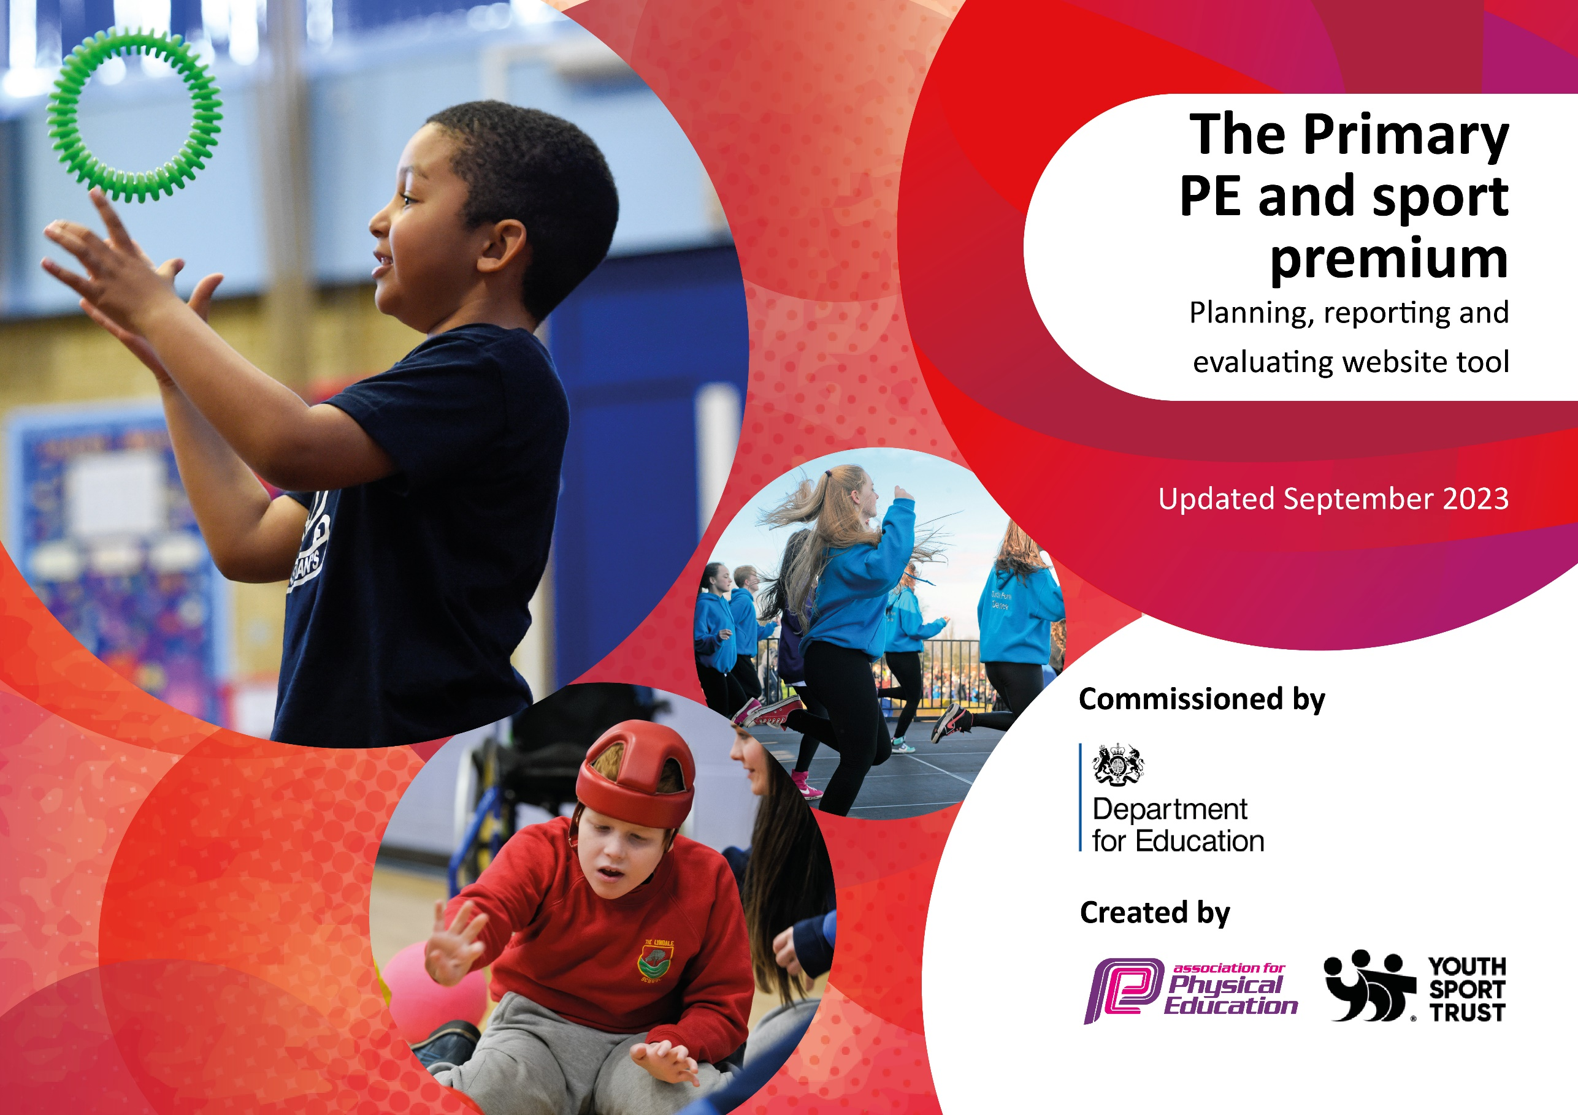

Thingwall Primary School – PE ACTION PLAN 2023_24

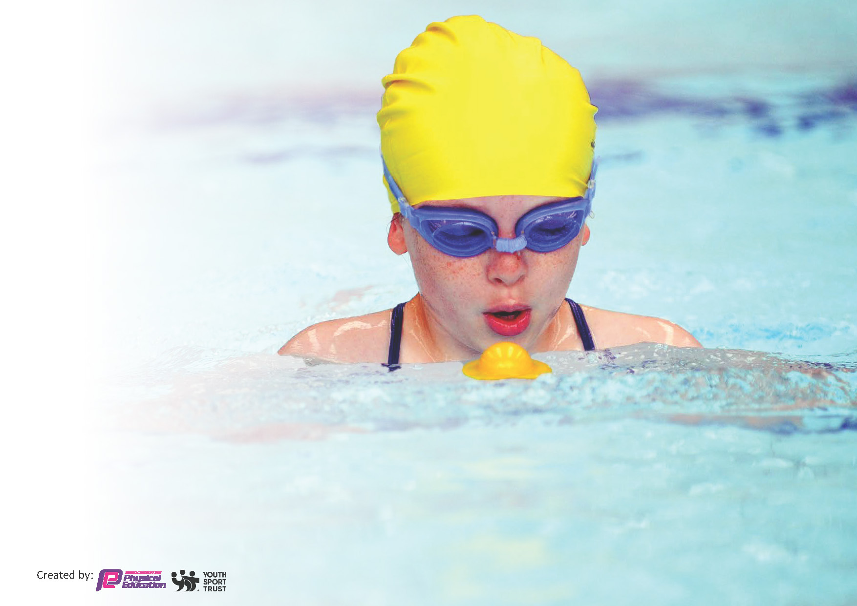
This template can be used for multiple purposes:
by:
- It enables schools to effectively plan their use of the Primary PE and sport premium
- It helps schools to meet the requirements (as set out in guidance) to publish information on their Primary PE and sport premium
- It will be an effective document to support Ofsted inspections enabling schools to evidence progress in Physical Education (PE) and evidence swimming attainment, which forms part of the PE National Curriculum. We would recommend schools consider
the Intent, Implementation and Impact of any spend, as examined within the Education Inspection Framework.

It is important that your grant is used effectively and based on school need.

Schools must use the funding to make additional and sustainable
improvements to the quality of the PE, School Sport and Physical Activity (PESSPA)
they offer. This means that you should use the Primary PE and sport premium to:

- Build capacity and capability within the school to ensure that improvements made now will benefit pupils joining the school in future years
- Develop or add to the PESSPA activities that your school already offers.

The Primary PE and sport premium should not be used to fund capital spend projects; the school’s core budget should fund these. Further detail on capital expenditure can be found in the updated Primary PE and sport premium guidance.

The Primary PE and sport premium guidance, outlines 5 key priorities that funding should be used towards. It is not

necessary that spending has to meet all the key priorities, you should select the priorities that you aim to use any funding towards.

Although completing this template is not a requirement for schools, schools are required to publish details of how they spend this funding. Schools must also outline what the impact this funding has had on pupils’ PE and sport participation and attainment and how any spending will be sustainable in the future. All funding must be spent by 31st July 2024.

The Department for Education has worked closely with the Association for Physical Education (afPE) and the Youth Sport Trust (YST) to develop this template and encourages schools to use it. This template is an effective way of meeting the reporting requirements of the Primary PE and sport premium.
Review of last year’s spend and key achievements (2022/2023)

We recommend you start by reflecting on the impact of current provision and reviewing your previous spend.

Activity/Action | Impact | Comments
Premier Sports ceased to operate from September 2022. The PE Coordinator has ensured that PE coverage has remained at pre-September 2022 levels, extending coverage to some activities including tag rugby. A new programme of dance (Key Stage 2) proved very successful, enjoyed by both teachers and pupils. Shared teaching during regular PE lessons, has supported ongoing CPD, resulting in quality lessons being delivered. This also supports sustainability of provision, moving forward.  We have continued to run a varied extra-curricular programme of sporting activities with improved attendance. External providers provide quality coaching and links with local clubs. We have also included activities fully accessible to SEN pupils, including Boccia and balloon tennis. Pupils took part in 2 very successful sports days, for FS2/Infants and Juniors. New raised planters have improved access for all pupils who enjoy gardening club, now open to pupils from across the school.  Our Eco project has resulted in a number of initiatives to improve the school grounds and as we embed outdoor learning across all subjects, pupils are regularly active in lessons.  Our Year 4 /5 football team took part in a local competition and went on to win a trophy in a tournament held at Tranmere Rovers Football ground. Volunteer parents have agreed to support the school football teams and input from one, undoubtedly, secured our success in the recent football tournament.  Years 5 and 6 went on residential outward bound trips this year, to Burwardsley and Min Y Don respectively. The latter was over 5 days and  Whole school initiatives included a visit from Freddie Fit and our ‘Walk to School’ week was well supported by parents and pupils in all year groups, benefitting all and promoting good habits across our wider school network.Bikeability supported active learning, teaching pupils how to keep safe when cycling.  School noticeboards and use of social media has kept the school community informed about PE developments.  New resouces purchased to ensure continued successful delivery of the curriculum. | All pupils in school enjoying opportunity to trial new sports and activities.  PE is taught by knowledgeable, confident, upskilled teachers who enjoy teaching the subject and are able to support the physical development of all pupils.  Increased staff confidence delivering PE and continuing to develop quality of provision.  By developing links across the curriculum, we have increased the opportunity for physical activity, including the outdoors and across the wider school community.  Involve the school community (parents, pupils and staff) in a wide range of physical activities. Engage with parents to support increased physical activity for all pupils (and families).  Pupils benefited from being away from home on outward bound activities, improving fitness, developing independence, personal responsibility, building self-esteem, supporting emotional health and wellbeing, improving decision making and enablilng social interaction. Also, developing life-long interests and addressing health and obesity issues.  Children experienced a wide range of physical outdoor activities, including climbing, abseiling, archery, canoeing, biking, orienteering and a range of team building activities. | Whole school audit to review PESSPA offer in school and to revisit ‘Vision’ in line with this document.  Extend active playground scheme to extend opportunities for all pupils to enjoy physical activity at playtimes  Take part in ‘Living Streets’ Walk to School events & continue to promote ‘Daily Mile’  To provide a wide range of physical activities across the PE curriculum (and clubs)  Extend physical activities outside of the PE curriculum  Increase number and breadth of competitions available both in and out of school

Key priorities and Planning
This planning template will allow schools to accurately plan their spending.

Action – what are you planning to do | Who does this action impact? | Key indicator to meet | Impacts and how sustainability will be achieved? | Cost linked to the action  Funding allocated: £17,820
1.Enable active playground scheme to extend opportunities for all pupils to enjoy physical activity at playtimes  Work with new lunchtime supervisors to ensure that all pupils enjoy regular physical activity in a safe environment  Appoint new Y5/6 Play Leaders (include less active Y6 pupils to support their physical development) to lead play activity on both playgrounds  Develop a half termly programme (with pupil input) to ensure that activities are age appropriate and accessible  Take part in ‘Living Streets’ Walk to School events  Actively promote across whole school (fun challenge and prizes for winning class  Continue to promote ‘Daily Mile’  Formalise with termly certificates for pupils (most laps, most improved etc) | Lunchtime supervisors are able to offer all pupils ideas for happy play  Pupils interacting happily together whilst enjoying active play (not just football!) showing increased support for their peers – happier children, happier playtimes!  - Higher percentage of pupils (all ages) involved in a wide range of age appropriate activities/games  - Opportunity for Y5/6 pupils to take on leadership roles  Increased number of pupils walking (or scooting) to school  Positive involvement in physical activity for wider community  Reduced congestion near to school  - Cleaner Air  - Environment gain  Increased motivation for pupils to improve/increase laps and therefore, physical fitness | Key indicator 1: The engagement of all pupils in regular physical activity – Chief Medical Officers guidelines recommend that primary school pupils undertake at least 30 minutes of physical activity a day in school | Lunchtime supervisors are confident in their ability to continue programme  Year 5 pupils are able to continue to support programme (& incoming Y5 pupils, when in Y6  Programme in place as a starting point for future development | Specialist PE teacher and PE curriculum lead employed part time to facilitate the actions on this plan.

2  Involve whole school community (parents, pupils, and staff) in a wide range of physical activities  Use Children’s mental health week to extend opportunities for additional physical activity e.g. Laura’s Dance Workshops, whole school Fitness Day with Freddie Fit and Lindy’s Rave (aerobics sponsored event)  Revisit to ensure that the PE curriculum is age appropriate and that the progression of skills is appropriate to each pupil’s PESSPA journey  Involve pupils in development of PESSPA initiatives including a number of ‘home-based’ projects  3.Audit to determine how best to support teachers’ development needs both in terms of lesson teaching and shared subject leadership  Specialist PE teacher to deliver one lesson of PE to each year group. Class teacher to observe and model strategies in further lessons.  Through monitoring, ensure that teacher knowledge is secure enabling skills to be developed in line with provision map  PE Lead to monitor teaching and pupil progress regularly (at least every half term)  Review assessment in line with MAT to ensure that it provides useful information so that lessons are adapted to support all pupils  Source possible platform offering bite-sized learning (& flexibility)  realPE  4.Invite external providers into school and organise fun events to be enjoyed by all pupils (& families)  E.g. Freddie Fit, Tennis for all, Walk to School, Nature Find….  Involvement in ‘Bikeability’  Take learning outdoors.  Subject coordinators to audit current outdoor provision and to seek out new opportunities to provide increased outdoor physical activity  Extend extra-curricular provision. E.g outward bound experience for wider range of pupils, gardening club and set up family activities/  challenges for the holidays  Y4-6 to attend swimming week  Y6 non-swimmers to be given the opportunity to attend further sessions  5. Increase number and breadth of competitions available both in and out of school  Support team development using volunteers from parent body or with links to local clubs eg. Calday Rugby Club  Participate in MAT wide competitions | Pupils  Parents  Staff  Sporting visitors  Athletes  Teacher knowledge  Pupil achievement  ECT leadership understanding  Pupils, staff (including subject coordinators), external providers, Bikeability team, parent volunteers  Pupils, staff (inc. office staff), sports coaches, parents  Increase opportunities for extending cultural capital of all participating MAT schools | Key indicator 2: The profile of PESSPA being raised across the school as a tool for whole school improvement  Key indicator 3: Increased confidence, knowledge and skills of all staff in teaching PE and sport  Key indicator 4: Broader experience of a range of sports and activities offered to all pupils  Key indicator 5: Increased participation in competitive sport | Increased number of pupils understand the importance of physical activity and enjoy their involvement in physical activity  More effective and progressive teaching and learning for all pupils in school  Increased enjoyment of physical activity over the long term  Increased opportunity to practise skills leading to improved physical literacy and enjoyment  Pupils able to represent school at competitions appropriate to the level of ability  Pupils are more motivated, practise in a focused way and enjoy competition showing teamwork, commitment, determination, perseverance, discipline and more sporting behaviour  Pupils learn to accept disappointment and understanding that healthy competition for team places is inevitable.  Intra school competitions provide opportunity for all pupils who are interested, to compete  Involve pupils and staff in a supportive role and work alongside staff who might be interested in greater involvement in PE in the future  Ensure that copies of all letters and other communication is available for future competitions  School is set up and prepared to host games  Ensure that there is a programme of investment for provision of resources

Key achievements 2023-2024
This template will be completed at the end of the academic year and will showcase the key achievements schools have made with their Primary PE and sport premium spending.

Activity/Action | Impact | Comments

Swimming Data
Meeting National Curriculum requirements for swimming and water safety.
Priority should always be given to ensuring that pupils can perform safe self-rescue even if they do not fully meet the first two requirements of the National Curriculum programme of study

Question | Stats: | Further context  Relative to local challenges
What percentage of your current Year 6 cohort can swim competently, confidently and proficiently over a distance of at least 25 metres? | 94% | Use this text box to give further context behind the percentage.  e.g., 30% - we are struggling to get pool space due to our local pool closing so we have had to use a much smaller local school pool. We have had to limit the number of pupils attending swimming lessons during one term which means some pupils have attended fewer swimming lessons than others.
What percentage of your current Year 6 cohort can use a range of strokes effectively [for example, front crawl, backstroke, and breaststroke]? | 90% | Use this text box to give further context behind the percentage.  e.g., Even though your pupils may swim in another year please report on their attainment on leaving primary school at the end of the summer term 2024

What percentage of your current Year 6 cohort are able to perform safe self-rescue in different water-based situations? | 87% | Use this text box to give further context behind the percentage.
If your schools swimming data is below national expectation, you can choose to use the Primary PE and sport premium to provide additional top-up sessions for those pupils that did not meet National Curriculum  requirements after the completion of core lessons. Have you done this? | Yes/No
Have you provided CPD to improve the knowledge and confidence of staff to be able to teach swimming and water safety? | Yes/No

Signed off by:

Head Teacher: | Ros Arden (DHT)
Subject Leader or the individual responsible for the Primary PE and sport premium: | Julie Yardley PE Lead
Governor: | Julian Rees (Parent Governor)
Date: | 25.01.24

