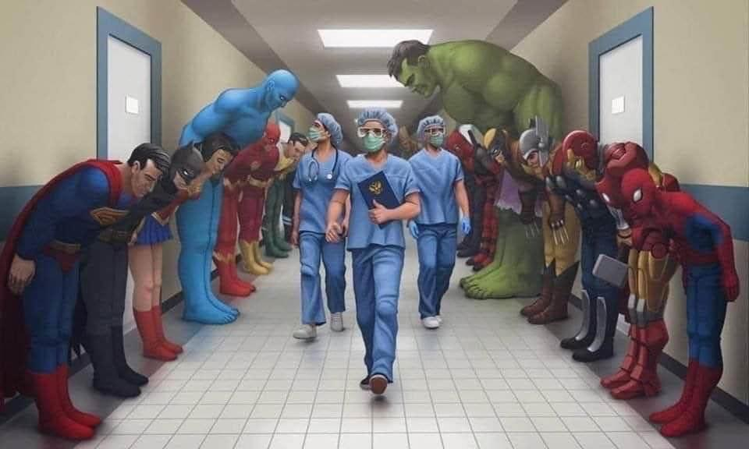
Superhero’s

Image is from The Literacy Shed
- Can you create a title for the image above?
- What message is the creator of this image trying to get across?
- Look at the image. Make a table on a piece of paper (see below) and try to think of 3 words for each column. Then try to use some of your words from your table to make a caption for the image.
Nouns | Verbs | Adjectives | Adverbs
Hero | Marching | Strong | Bravely

I have given you a word in each column to help and there is a small explanation of each underneath here.

Noun – The name of place, person or thing.
Verb – A verb often names and action.
Adjective – These give more information about the noun.
Adverb – These give you more information about the verb.

