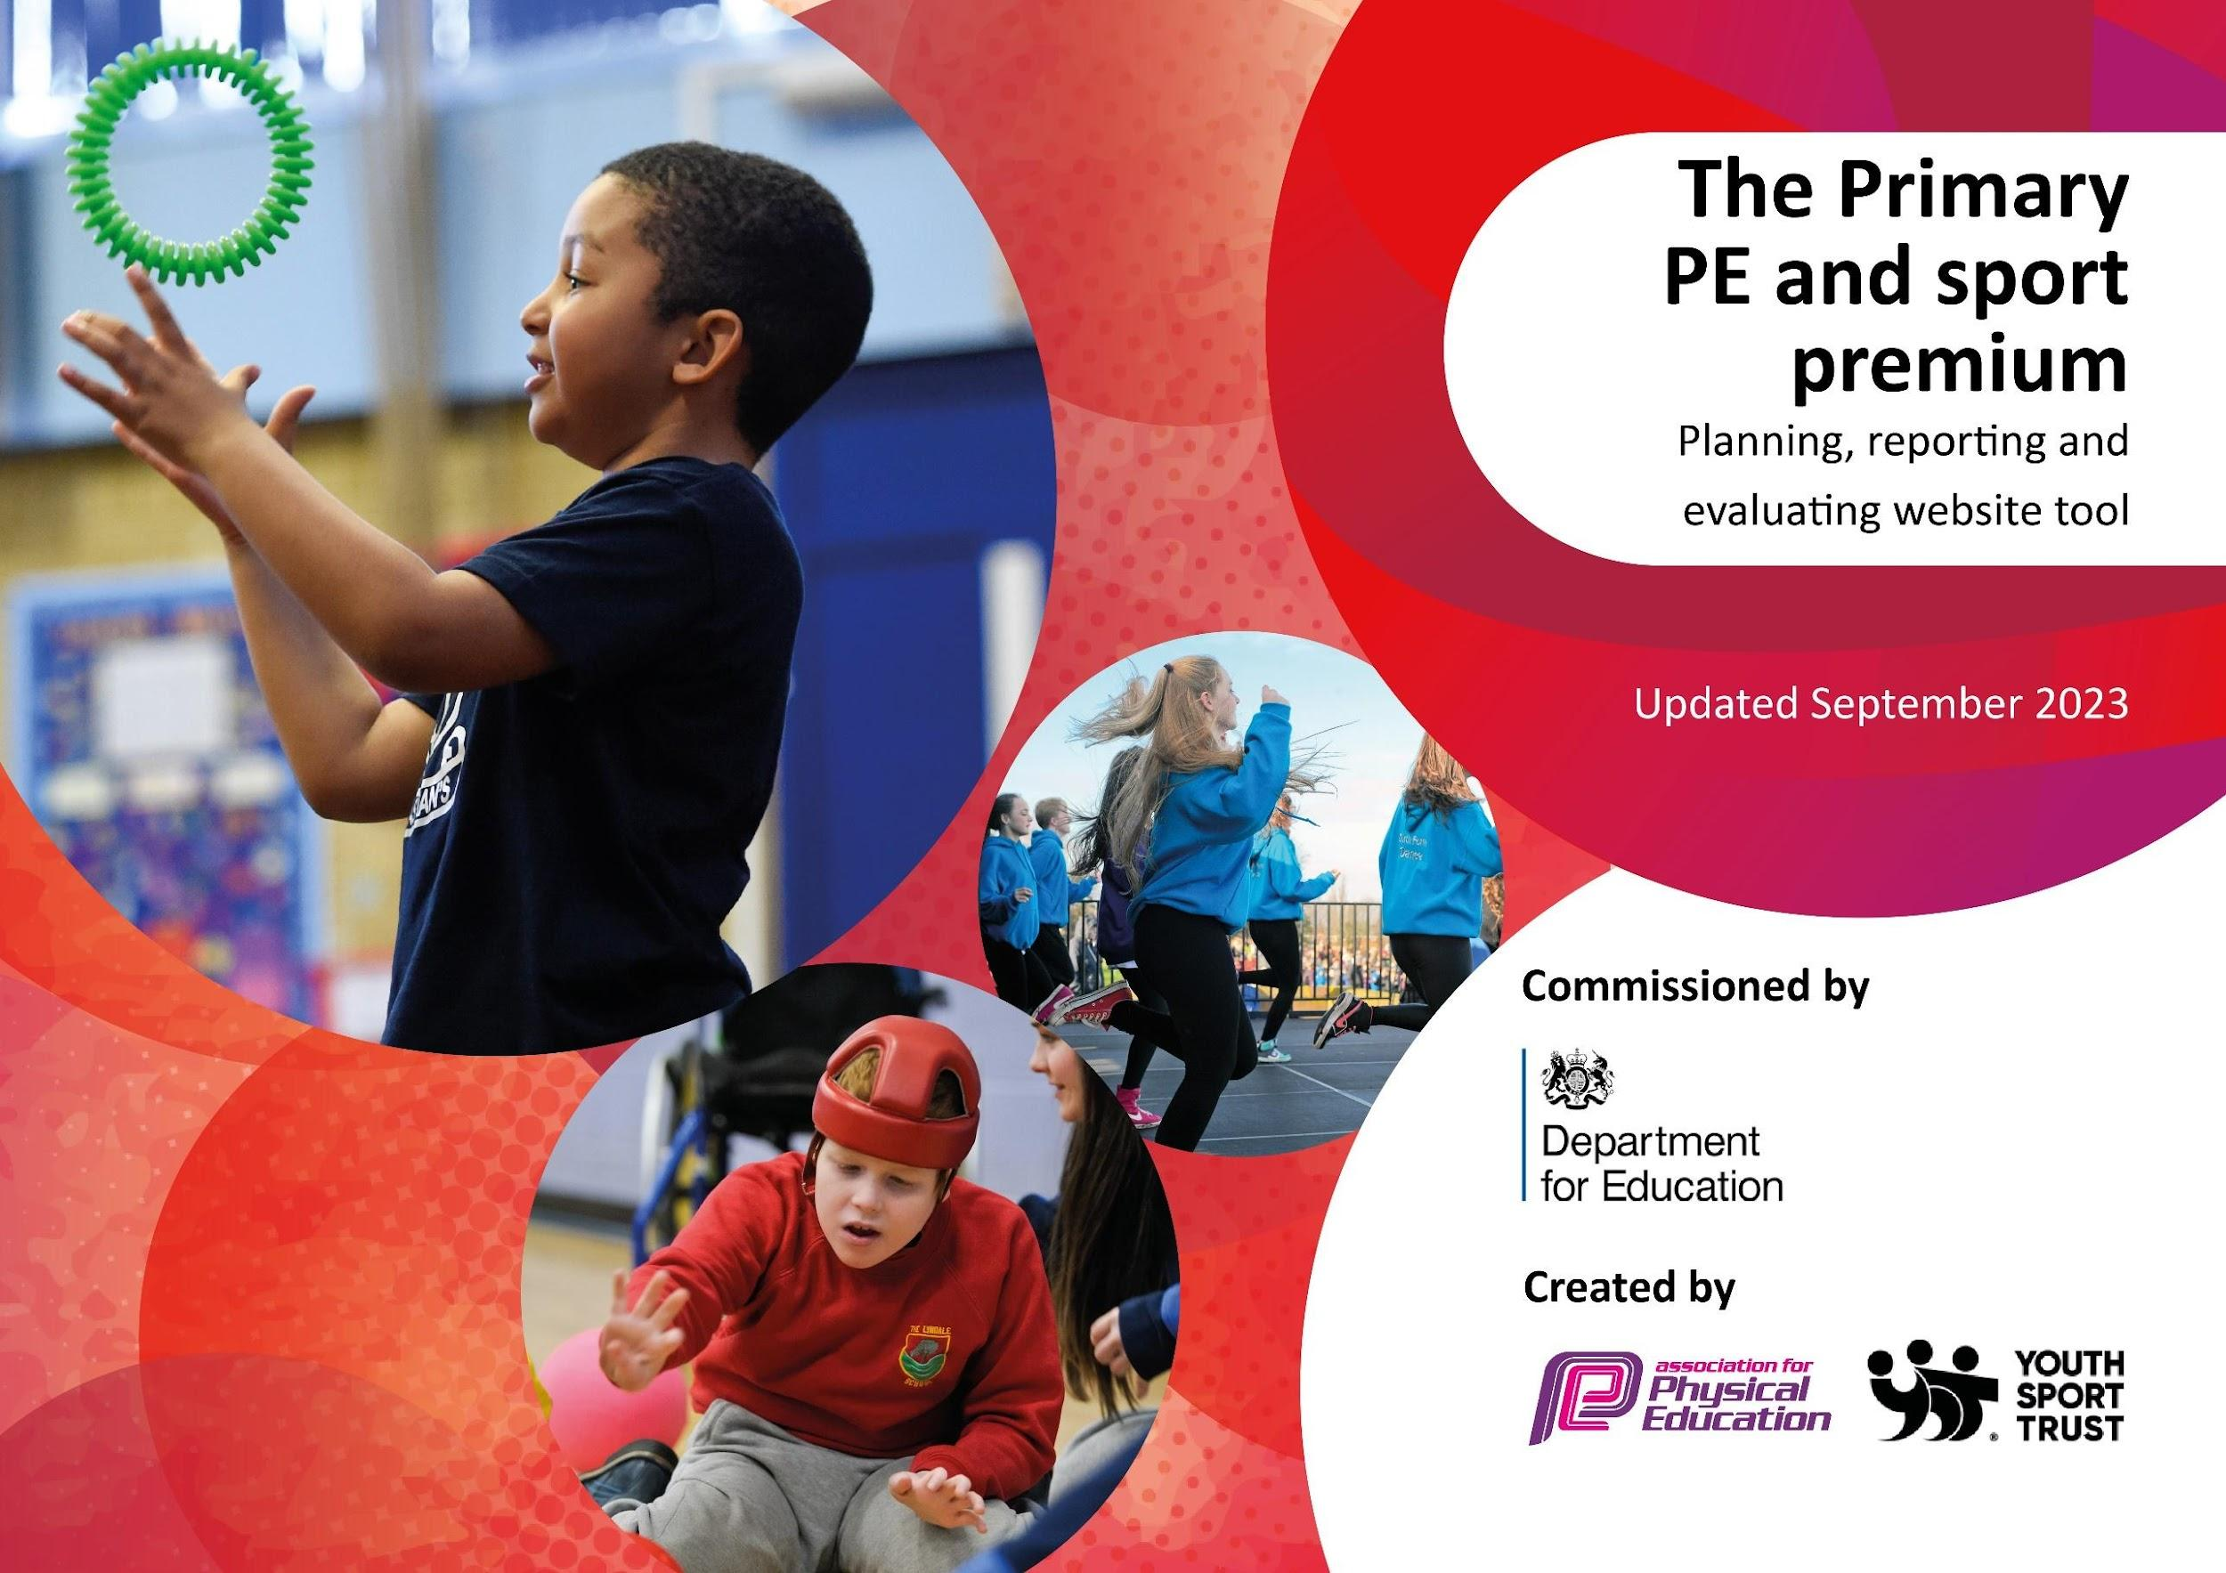

THINGWALL PRIMARY SCHOOL
Review 2023 to 2024 and Development 2024 to 2025

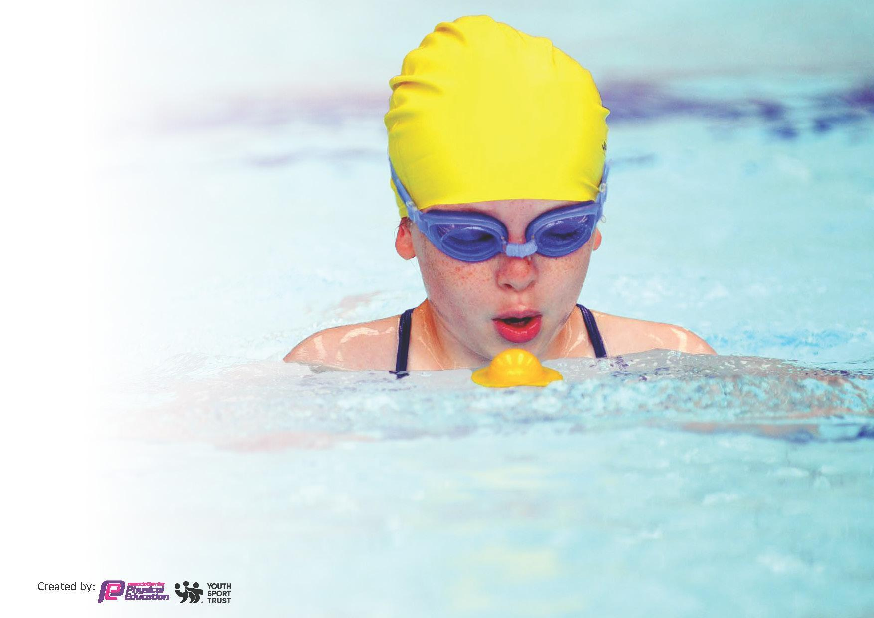
This template can be used for multiple purposes:
by:
- It enables schools to effectively plan their use of the Primary PE and sport premium
- It helps schools to meet the requirements (as set out in guidance) to publish information on their Primary PE and sport premium
- It will be an effective document to support Ofsted inspections enabling schools to evidence progress in Physical Education (PE) and evidence swimming attainment, which forms part of the PE National Curriculum. We would recommend schools consider
the Intent, Implementation and Impact of any spend, as examined within the Education Inspection Framework.

It is important that your grant is used effectively and based on school need.

Schools must use the funding to make additional and sustainable
improvements to the quality of the PE, School Sport and Physical Activity (PESSPA)
they offer. This means that you should use the Primary PE and sport premium to:

- Build capacity and capability within the school to ensure that improvements made now will benefit pupils joining the school in future years
- Develop or add to the PESSPA activities that your school already offers.

The Primary PE and sport premium should not be used to fund capital spend projects; the school’s core budget should fund these. Further detail on capital expenditure can be found in the updated Primary PE and sport premium guidance.

The Primary PE and sport premium guidance, outlines 5 key priorities that funding should be used towards. It is not necessary that spending has to meet all the key priorities, you should select the priorities that you aim to use any funding towards.

Although completing this template is not a requirement for schools, schools are required to publish details of how they spend this funding. Schools must also outline what the impact this funding has had on pupils’ PE and sport participation and attainment and how any spending will be sustainable in the future. All funding must be spent by 31st July 2024.

The Department for Education has worked closely with the Association for Physical Education (afPE) and the Youth Sport Trust (YST) to develop this template and encourages schools to use it. This template is an effective way of meeting the reporting requirements of the Primary PE and sport premium.

Schools must use funding to make additional and sustainable improvements to the quality of PE School Sport and Physical Activity (PESSPA).

In 2023 – 2024 Thingwall Primary School was allocated £17,820
In 2024 – 2025 Thingwall Primary School was allocated £17,770

Summary Review of last year’s key achievements (2023/2024)

We recommend you start by reflecting on the impact of current provision and reviewing your previous spend.

Activity/Action | Impact | Comments
Increased supervision at playtimes, enabling greater opportunities for all pupils to enjoy physical activity at playtimes. This initiative is supported by Y5 & Y6 playleaders and led by midday supervisor, NM. | Lunchtime supervisors confident in their ability to coordinate activities for pupils, improving the quality of physical activity at play | Calmer, happier children actively engaged at playtimes through more purposeful play and refereed football. Children are given the opportunity to practice skills taught in lessons.
Continuation of Living Streets, Walk to School initiative Children record how they travel to school to earn stickers and certificates | Healthier children (& families) aware of the need for exercise to enjoy good health.  Purchased resources have supported engagement in the initiative and led to less traffic issues outside school and a greater number of families walking/cycling/scooting into school. | Successful initiative, taken back by PE Leads to OTMAT who have agreed to fund again for 24-25.
Mental Health Week to allow for additional physical activities, as voted for by the School Council. | All pupils in school involved in activities to improve mental and physical wellbeing. | Rave with Lindy was very well received and Freddy Fit re-emphasised the need to achieve a balance in our life between physical activity and mental health/well-being.
Curriculum support for teachers during lessons from TPS Sports Coach and CPD training from experienced qualified gymnastics coach and British Judo Coach (in lessons and twilight training sessions) | Improvement in teaching and learning in PE lessons with pupils achieving improved outcomes and progressing towards British Gymnastics and British Judo certificates. | Staff more knowledgeable and confident, teaching a broad range of PE activities during the year. Monitoring shows an increased quality of PE teaching.
TPS Sports Coach provided bespoke training for ECT PE Specialist and adopted a coaching role within PE lessons for ECT. | RQT is now leading PE in Dubai, having secured a promotion to teach as a specialist Sports Coach. | Intend to repeat this approach next year for newly appointed PE ECT.
Continue to promote outdoor learning and seek new opportunities for physical activity e.g. Forest Schools, Residentials for Years 5 and 6. | Pupils in Years 5 and 6 gained experience in a number of outdoor pursuits at Min Y Don and Edsential’s Burwardsley OEC | Accessed by all Y5 and 6 pupils, including those who would have normally been precluded from attending due to financial constraints.
Extended extra-curricular provision to provide a broader appeal to pupils e.g. two morning gymnastics clubs for KS1 & KS2 pupils and two football clubs, 1 mixed and 1 for girls and 1 X judo club. These clubs are led by specialist coaches. | Increased enjoyment of physical activity over the longer term  All pupils achieving their British Gymnastics Core Skills awards. Invited to demonstrate skills at School Summer Fair and end of year assemblies to encourage future take up of clubs. Improved physical strength and flexibility starting with pupils in KS1. | Pupils can now gain accreditation for British Judo, British Gymnastics and represent local and regional teams, with one past pupil going on to represent England for Judo.
Continued involvement in competitions in & out of school | Intra school competition (including preparation for Sports Days) providing opportunity for all pupils to compete in school, reginal and MAT events.  Teams more involved in local tournaments, with wins for both mixed and girls only teams.  Increased motivation and improved fitness and skill levels.  Development of important values through teamwork – commitment, determination, perseverance, discipline in addition to learning to win and lose graciously | Increased profile of sports across school means that more families and pupils are engaged and there are overall increased levels of good health.
Clubs for more vulnerable pupils. Lunchtime basketball club for SEMH pupils promoting inclusion, team building and small group experience with a qualified member of staff. | Development of teamwork and social skills, increased enjoyment in team and competitive sports for vulnerable pupils.  After participating in lunchtime small group sports sessions, vulnerable SEMH pupils were more able to engage in afternoon curriculum lessons and were visibly more confident. | Children have been supported to remain in school and develop a teamwork approach to collaborative play.
SEND Support to improve accessibility for all. Additional staff employed to facilitate after school sports club participation for pupils with physical disabilities. | Increased engagement in a range of after school extra-curricular sports sessions for pupils with physical disabilities | Greater uptake for cricket and boccia clubs which has led to a pupil attending Upton Cricket Club.
Mental Health support sessions with Pastoral@Greasby, CAMHs and Flourish. | Individuals, groups and their families have been signposted to local resources/agencies for bespoke support.  Team Around the Child approach has ensured effective multi-agency work which has supported pupil well-being. | Children have been supported to remain in school, attendance of PA pupils has improved and team around the child approach has meant that the child has been at the centre of every decision made in collaboration with their families/carers.
Swimming for more able pupils in Y6 and for Y4 and Y5 | Y4&5 swimming has led to an increase in the end of KS2 expectations for Year 6 pupils, meaning a greater than usual proportion can swim 25m. | Ensure monies are allocated to enable Y4&5 to take part in intensive swimming sessions for 24-25.

Swimming Data 2023 to 2024

Meeting National Curriculum Requirements for Swimming and Water Safety 2023 - 2024
 | Percentage | Other comments
% Year 6 pupils who can swim competently, confidently and proficiently over a distance of at least 25 metres | 94%
% Year 6 pupils who use a range of strokes effectively (for example, front crawl, backstroke and breaststroke) | 90%
% Year 6 pupils who can perform safe self-rescue in different water based situations | 87%
If your schools swimming data is below national expectation, you can choose to use the Primary PE and sport premium to provide additional top-up sessions for those pupils that did not meet National Curriculum requirements after the completion of core lessons. Have you done this? | No | Not required this year, however, we will keep this under review
Have you provided CPD to improve the knowledge and confidence of staff to be able to teach swimming and water safety? | No | Staffing qualifications/experience are good We will keep this under review

Key Priorities and Planning 2024 to 2025

This planning template will allow schools to accurately plan their spending.

Action – what are you planning to do | Who does this action impact? | Key indicator to meet | Impacts and how sustainability will be achieved? | Cost linked to the action
Create further opportunities for SEND/pupil premium involvement in extra-curricular activities, ensuring inclusion and celebrating diversity  Including:  -MAT track and field event at Hilbre High School for LKS2  -Purchase equipment to facilitate adapted and disability sport  -Purchase equipment to enhance extra-curricular provision for Pupil Premium pupils  -Establish opportunities for sitting benchball, volleyball, badminton, boccia etc through Diversity Day supported by local special school staff | Pupils  PE coordinator  Teaching staff | Key indicator 2 -The engagement of all pupils in regular physical activity | More pupils meeting their daily physical activity goal, more pupils encouraged to take part in PE and Sport Activities.  Pupils with SEND and those in receipt of Pupil Premium will have greater opportunities to participate in a range of sporting activities.  Increased awareness of others’ needs and working together to support these, stronger links with local high schools will be established . | Transport to Hilbre High School  £500  Equipment to facilitate adapted and disability sport £1000  Release for Claremount/WKRS teaching staff (4 x£180) £720
Enable more pupils to represent the school in sport by:  -Participating in tournaments facilitated by Activity for All  -Participating in OTMAT team building outward bounds collaborative day at Barnstondale  -Creating a girls’ football team facilitated by Wirral Phoenix FC  -Staff to facilitate additional extra-curricular clubs (netball, cross country) and accompany pupils to after school events to enable them to take part in Wirral events and tournaments  -Hosting football and other sporting competitions on our school field | Visiting sports coaches  Pupils  Teaching staff | Key indicator 5: Increased participation in competitive sport  Key indicator 2: Engagement of all pupils in regular physical activity  Key indicator 4: Broader experience of a range of sports and activities offered to all pupils  Key indicator 3: The profile of PE is raised across the school | Team building skills and applying tactics to competitive situations  Learning sportsmanship, increased confidence and participation  Raises profile of full participation in physical activity and its importance in promoting physical and emotional wellbeing | Activity for All- £300  Transport to tournament events £1500  Contribution for Barnstondale event £150  Wirral Phoenix Coach £2160  All weather FA approved goal posts £800  Pitch marking on field £200  TPS Sports Coach overtime to facilitate competitions £1000
All teaching staff work weekly alongside TPS PE Coach who is providing additional CPD to enable teachers to provide continuity and progression of PE teaching and skills  British Gymnastics coach providing bespoke staff CPD in the delivery of gymnastics | Teaching staff  Pupils | Key indicator 1: Staff CPD & increased confidence, knowledge and skills of all staff | Increase in knowledge of pedagogy and strengthening staffing expertise enabling teachers to provide expert teaching across key stages | Overtime for TPS Aports Coach to facilitate staff CPD £600- 1 staff meeting per half term
Provide a week of intensive swimming tuition per year for Y4+5 pupils  Provide swimming enhancement for competent Y6 swimmers  Additional ASA approved swimming teacher to support inclusion for pupil who requires in pool tuition  Additional staff to facilitate access to changing pupil with mobility issues  Provide training for ASA swimming qualification for 2 x ECTs | Teaching staff  Y4,5,6 pupils | Key indicator 1: Staff CPD & increased confidence, knowledge and skills of all staff  Key indicator 2: Engagement of all pupils in regular physical activity  Key indicator 4: Broader experience of a range of sports and activities offered to all pupils | Greater number of pupils will be able to swim 25m unaided by the end of y5 enabling competent swimmers in y6 to gain higher level swimming skills  Pupil with mobility issues is enabled to have equal access to the curriculum  Teaching staff improved knowledge and pedagogy enabling school teaching staff to facilitate swimming lessons going forward | £3500  ASA £380 x 2  Release for ECTs x 2 days = £720
Hold our annual ‘Healthy Body Healthy Minds Week’ to raise the profile of positive mental wealth and appreciate the benefits of regular exercise and a balanced diet and their impact on our well-being  Additional activities will include:  -Freddy Fit for R-Y6  -Mrs Prance Dance R-Y6  -Flourish Confidence Counts Sessions  -CAMHS in schools- friendship sessions  -Edsential healthy foods promotion week | Teaching staff  Pupils  Parents | Key indicator 2: Engagement of all pupils in regular physical activity  Key indicator 3: The profile of PE is raised across the school  Key indicator 4: Broader experience of a range of sports and activities offered to all pupils | Pupils and families will have the opportunity to participate in a range of activities which will provide skills that they can use to support their own mental health and well-being for now and the future  Increase in confidence, resilience, relationships and positive mental well-being | Freddy Fit  £450  Mrs Prance Dance £450  Flourish £185  CAMHS- £0  Edsential £100
Provide bespoke mental health support for identified vulnerable pupils and their families.  -Joanna Walker- Pastoral @Greasby (x1 day/week)  -CAMHS in schools  -Hive Lemonade Project  -Flourish- bespoke support for vulnerable pupil | Pupils  Parents | Key indicator 4: Broader experience of a range of sports and activities offered to all pupils | Pupils and families benefit from bespoke specialised support to enable them to access local services and initiatives in order to improve mental health and well-being in the long term and enabling them to be more independent in self care. | JW £6000  £0  £0  £0  £0  Flourish £400
Release of PE lead, two ECTs and shadow coodinator to attend curriculum updates and CPD |  | Key indicator 1: Staff CPD & increased confidence, knowledge and skills of all staff | Increase in knowledge of pedagogy and strengthening staffing expertise by ensuring sustainability | £1000

Key achievements 2024-2025
This template will be completed at the end of the academic year and will showcase the key achievements schools have made with their Primary PE and sport premium spending.

Activity/Action | Impact | Comments

Swimming Data 2024-2025
Meeting National Curriculum requirements for swimming and water safety.
Priority should always be given to ensuring that pupils can perform safe self-rescue even if they do not fully meet the first two requirements of the National Curriculum programme of study

Question | Stats: | Further context  Relative to local challenges
What percentage of your current Year 6 cohort can swim competently, confidently and proficiently over a distance of at least 25 metres? | % | Use this text box to give further context behind the percentage.  e.g., 30% - we are struggling to get pool space due to our local pool closing so we have had to use a much smaller local school pool. We have had to limit the number of pupils attending swimming lessons during one term which means some pupils have attended fewer swimming lessons than others.
What percentage of your current Year 6 cohort can use a range of strokes effectively [for example, front crawl, backstroke, and breaststroke]? | % | Use this text box to give further context behind the percentage.  e.g., Even though your pupils may swim in another year please report on their attainment on leaving primary school at the end of the summer term 2024

What percentage of your current Year 6 cohort are able to perform safe self-rescue in different water-based situations? | % | Use this text box to give further context behind the percentage.
If your schools swimming data is below national expectation, you can choose to use the Primary PE and sport premium to provide additional top-up sessions for those pupils that did not meet National Curriculum  requirements after the completion of core lessons. Have you done this? | Yes/No
Have you provided CPD to improve the knowledge and confidence of staff to be able to teach swimming and water safety? | Yes/No

Signed off by:

Head Teacher: | (Name)
Subject Leader or the individual responsible for the Primary PE and sport premium: | Julie Yardley
Governor: | (Name and Role)
Date: | 16/07/2024

