My Lockdown Poem

I love going on bike rides,
And finding new places to explore.
I’m looking after many plants,
Watering them each day.
They were small and weak,
But now they’re large and green
And they are getting larger every hour.
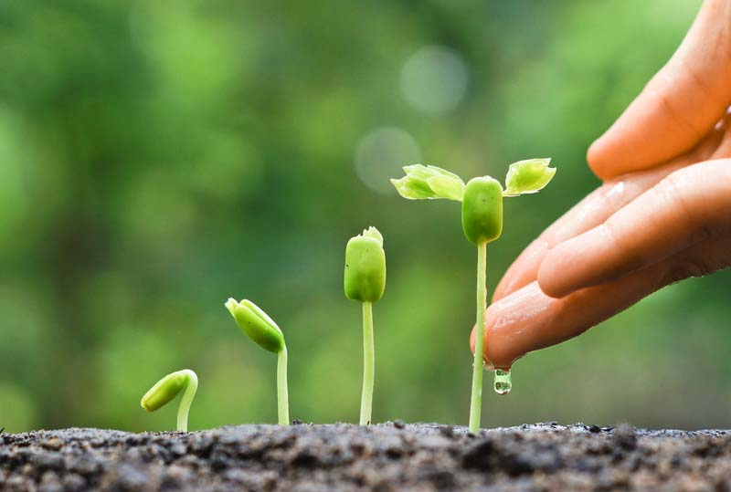
I miss the yard so much,
Even though we visit on Sundays
It is still not enough.
The past few weeks we have been cooking many, many things
From cheesecake to fish pie,
Everything we need.
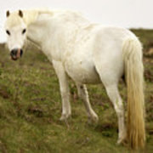

Buster has been with us for quite a long time,
He fits in well and always wants a cuddle
He has everything we love,
And we will miss him
When he’s gone.
Walking him is a tonne of fun,
He runs along with us too.
The only things we don’t like
Is that he sniffs and sniffs
And doesn’t do a poo!
School work is hard and boring,
We never want to do it
Although there may be some fun too!
Like PE or art,
Maybe science too.
When we finish
We call family or friends.
We will play tonnes of games
And hope it never ends!

By Sophie Flaxman

