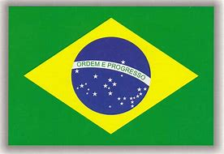
BRAZIL

- Brazil is in South America and its official name is The Federal Republic of Brazil.
- The capital of Brazil is Brasilia.
- Brazil is the 5th largest nation in the world.
- Brazil has a 7,400km coastline along the Atlantic Ocean.
- The population of Brazil is 183,888,841.
- The official language of Brazil is Portuguese.
- The area of Brazil is 8,511,965km²
- There are 2 major mountain ranges in Brazil. These are Serra do Mar and Serra do Espinhaco. Serra do Espinhaco is the largest mountain range in Brazil in the area it covers. Mountains in Brazil have an average height of 2,000 metres.
- The major rivers in Brazil are Amazon, Sao Francisco, Parana, and Tocantin.
- The Amazon river is 6,840km long and thousands of species live in it.
- The landscape of Brazil has dry grasslands, hills, pine forests, wetlands, plateaus, a long coastal plain and the world’s largest rainforest.
- Brazil’s biggest cities are Sao Paulo and Rio de Janeiro. 43% of the population live in these cities which cover 11% of the country.
- Many people immigrated to Brazil in the 19th century which has made the country diverse.
- Brazil has won the FIFA World Cup 5 times! More than any other nation.
- The world’s largest carnival happens in Brazil each year. They enjoy music, dancing, costumes and parades and 2 million people go.
- Brazil has the most species of animals of any country in the world.
- Brazil has the world’s largest wetland called, Pantanal.
- Deforestation has become a major problem. Most of the rainforest has gone and more disappears each year. The government and charities and trying to protect the rainforest.

